**Book Store**

**Description:**

The book Store shopping, the user can enter in to the application using of entering the User Name and mail id. Once entered it will redirect to Homepage of the Book store.

All available books displayed and search option in home page. Based on the user selection in the book clicking of **Buy Now** link in the corresponding book, the book will be selected and it will show the specific details of the book. There will be a button to add the cart.

Once done adding the cart, the buy option is there to buy the selected books. Again you can come back to home page clicking of **Book Store** Link.

There is option to view the selected books available in cart before buying the books on click of **My Cart.**

**Technologies :**

Language : Java 1.8, Servlet, ,JSP,

Server : Apache Tomcat 7,

Webservice : Jersey Restful webservice,

IDE  : Eclipse Java EE IDE for Web Developers.

**GUI Functionalities:**

1. Login
2. Display All books in Stock
3. Option to select one book to Purchase
4. Search the Particular Book
5. Add Cart
6. View the cart
7. Buy the book

Known Issues:

1. Search option entering word working fine. Some more specific search working on it.

**Command Line Functionalities:**

1. Display All books in Stock
2. Option to select the books
3. Stock validation before buying the book
4. Adding cart
5. Search option
6. Buying the selected books

Known Issue:

1. Remove from Cart- reducing the Cart value.

**Snapshot’s of the actions:**

**Login Page:**

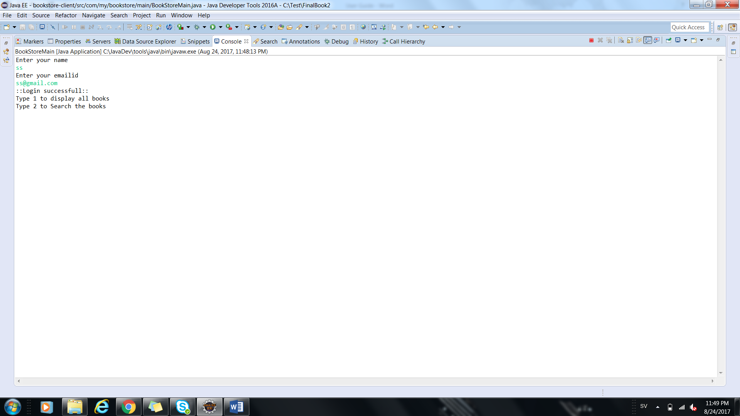

Display All books:

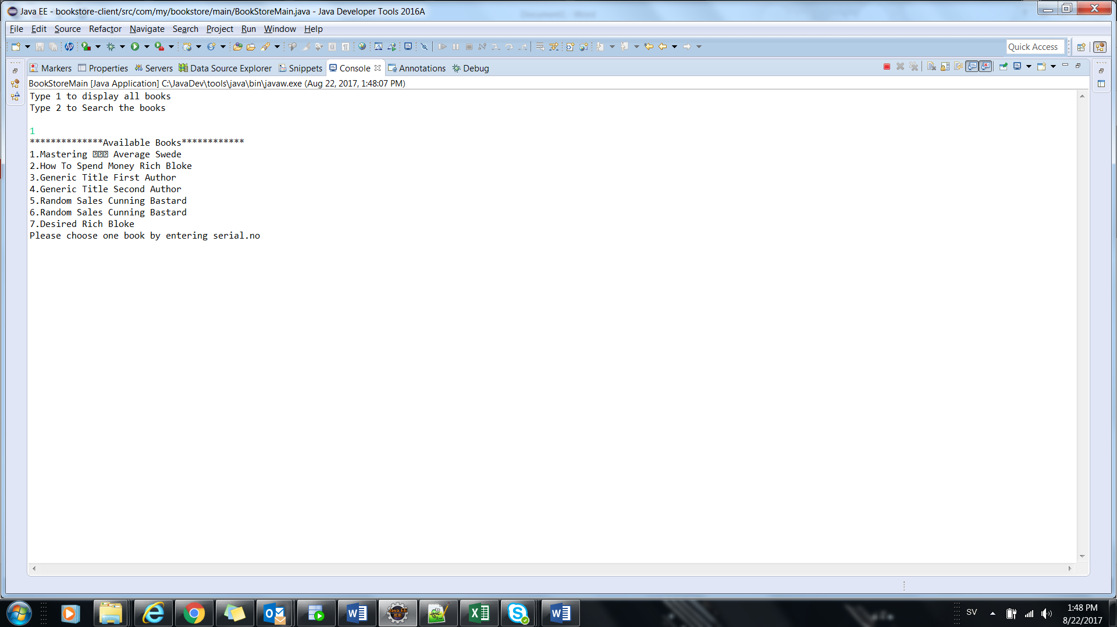

**Book Purchase and in Cart:**

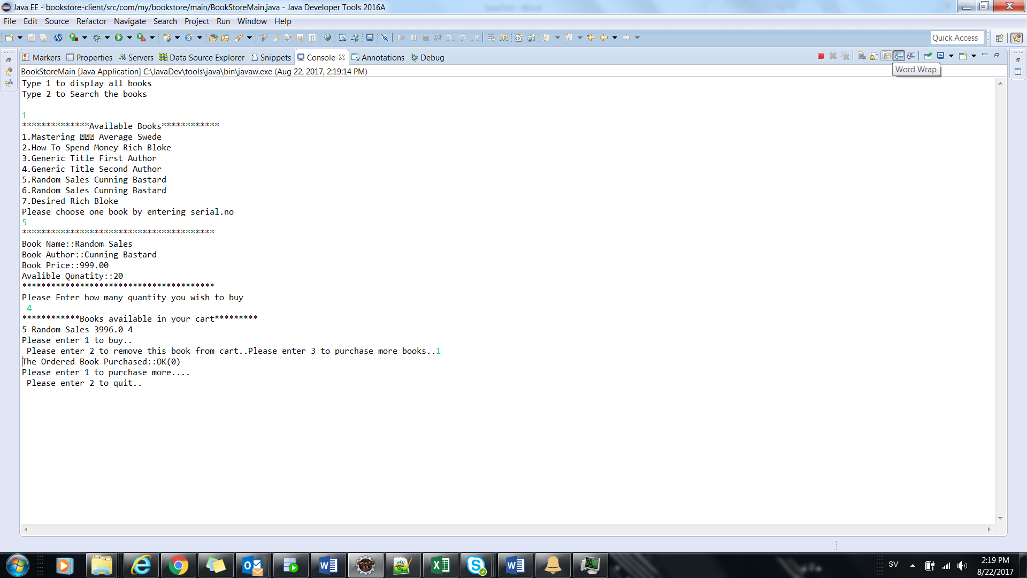

**Remove from Cart:**

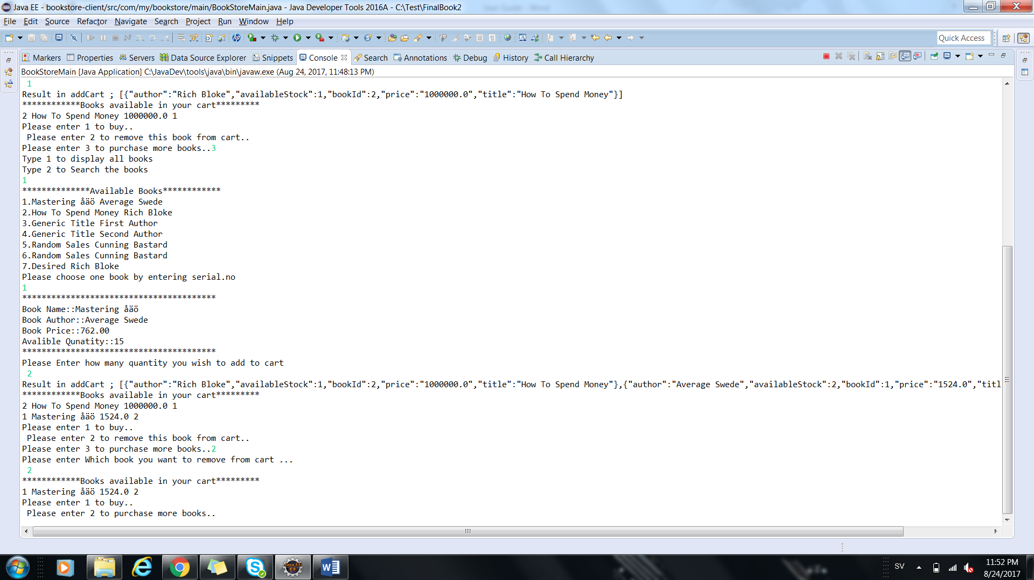

**More books buying and books in Cart:**

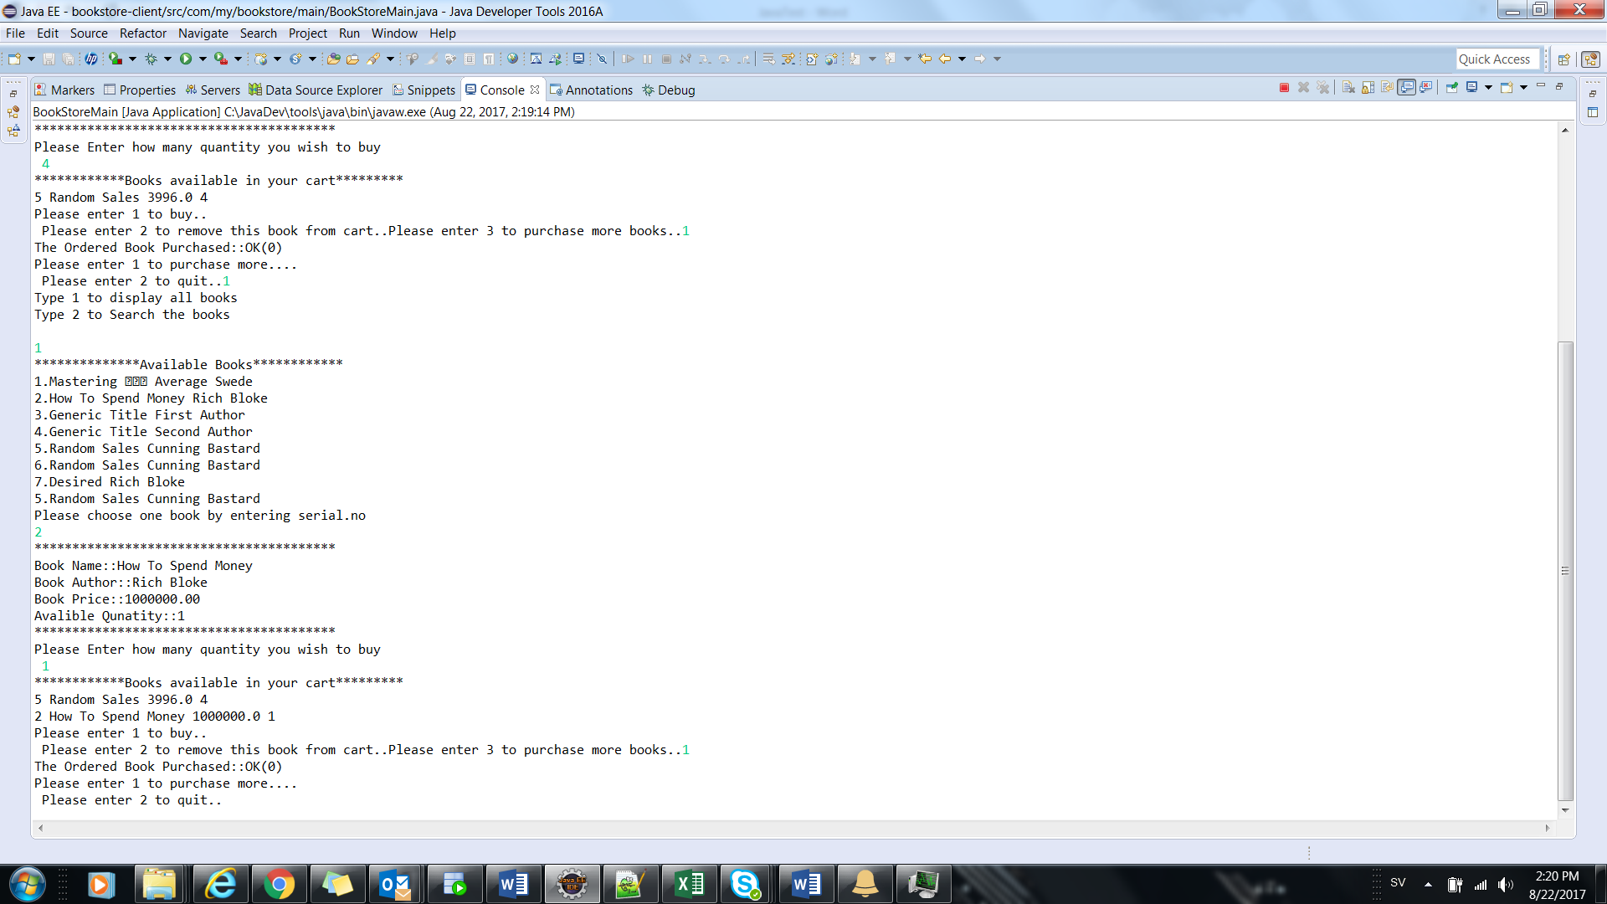

**Search Option and Book buying:**

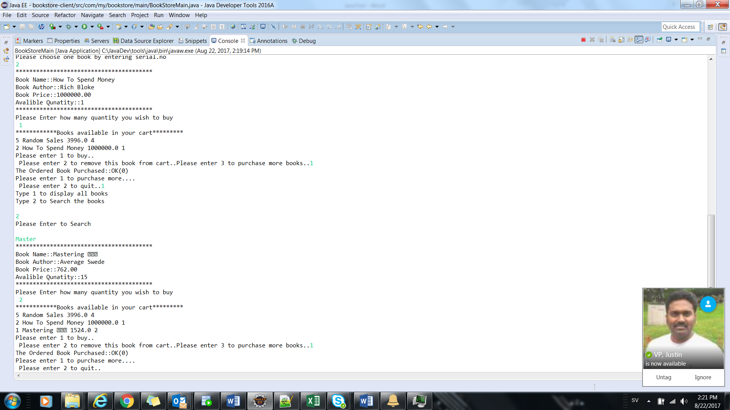

**Available stock verification before buying:**

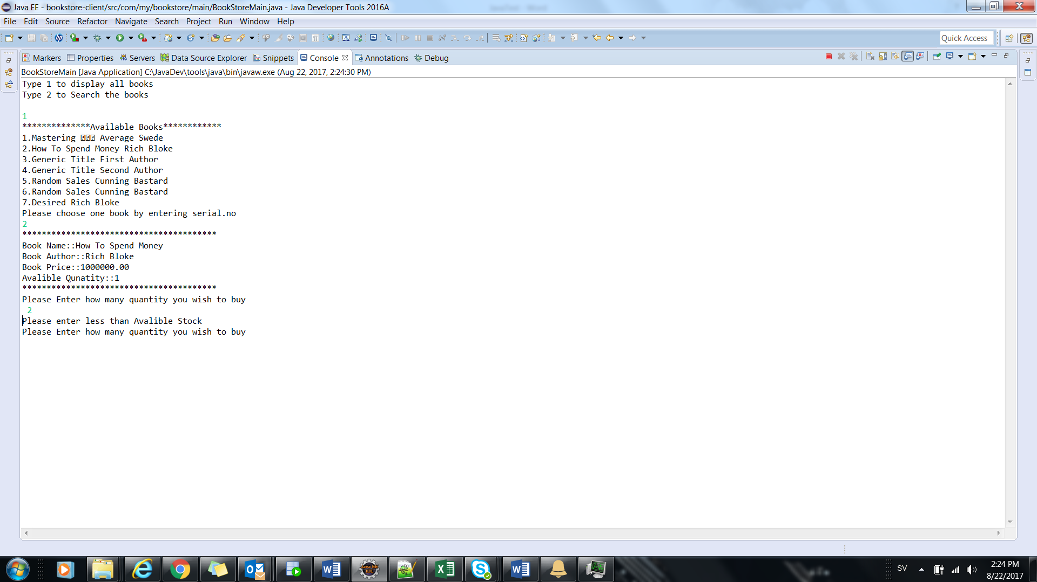

**GUI:**

**Login Page:**

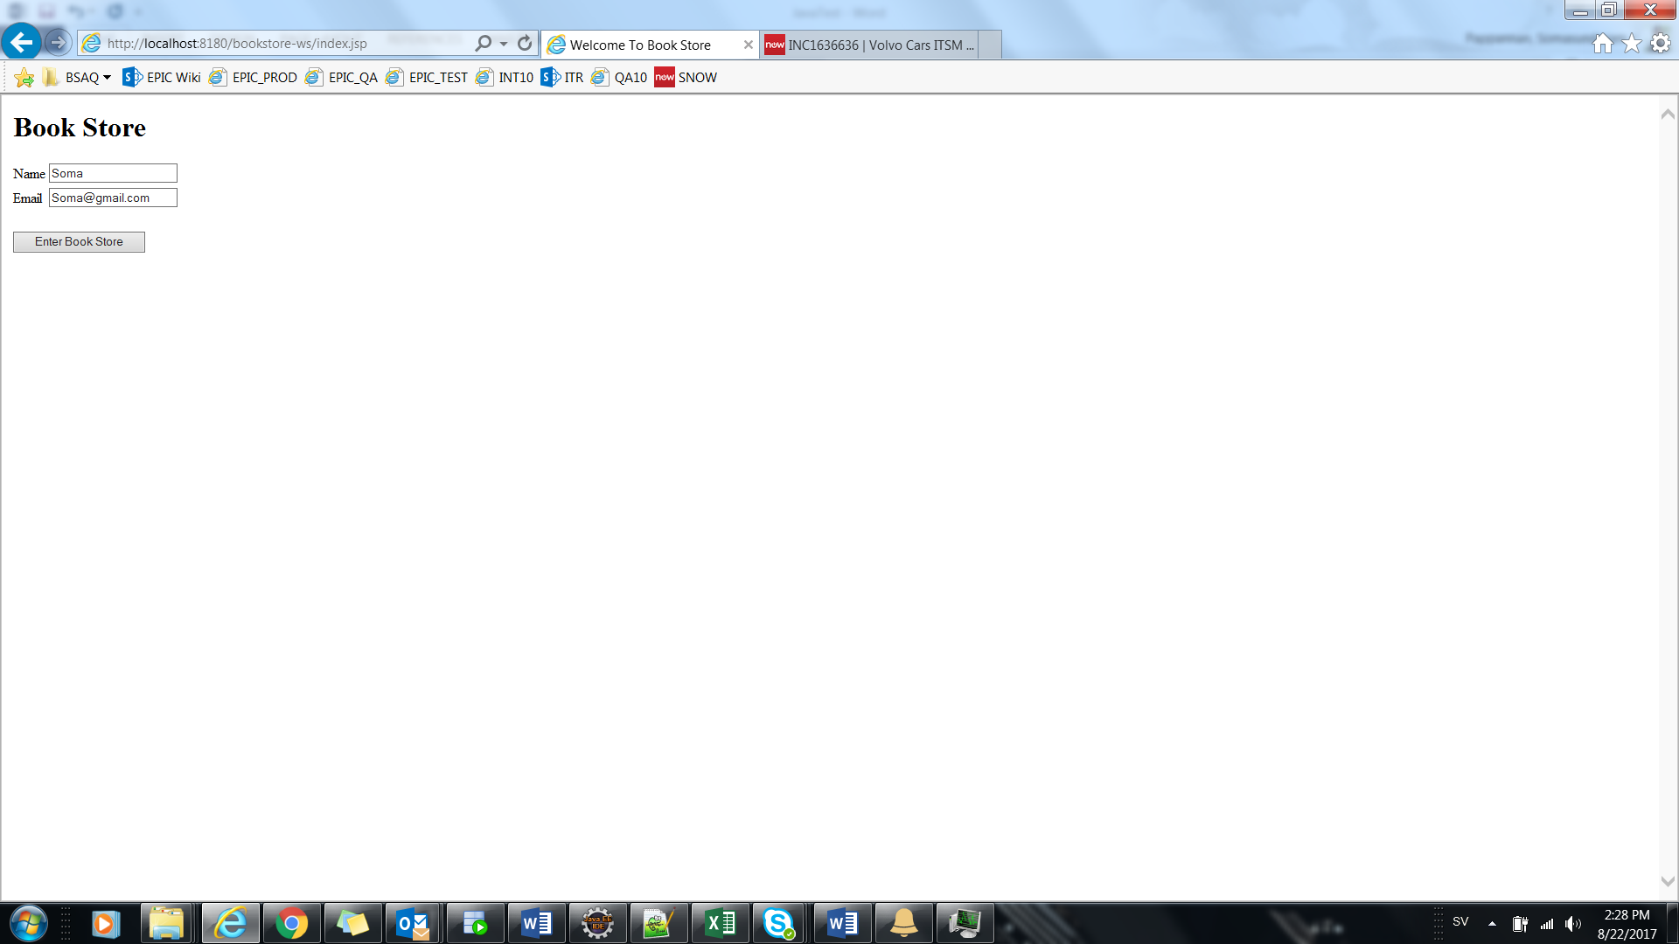

**Books Display:**

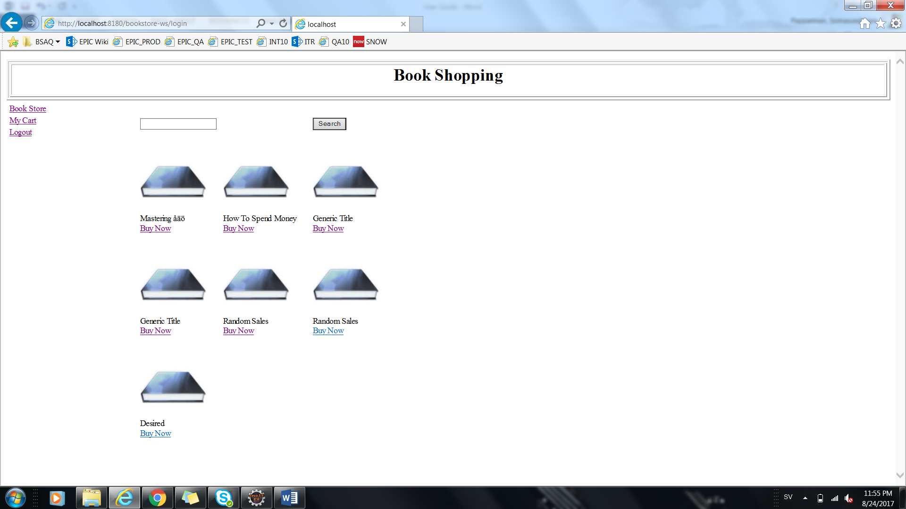

**Selection Particular book and entering the Quantity:**

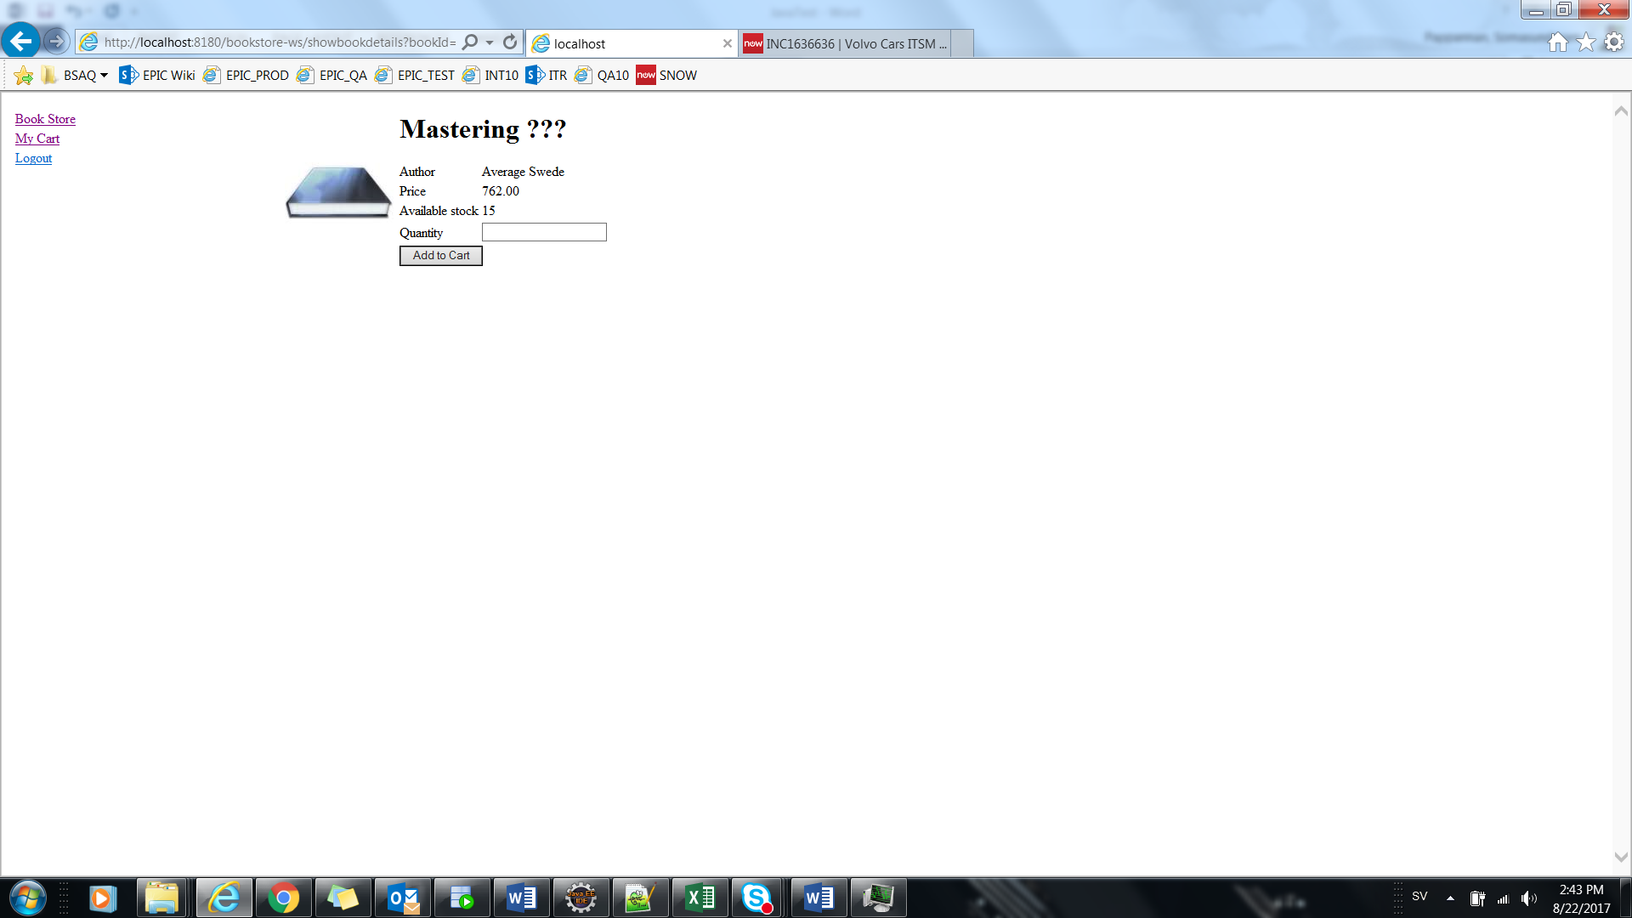

**Success Message after adding Cart:**

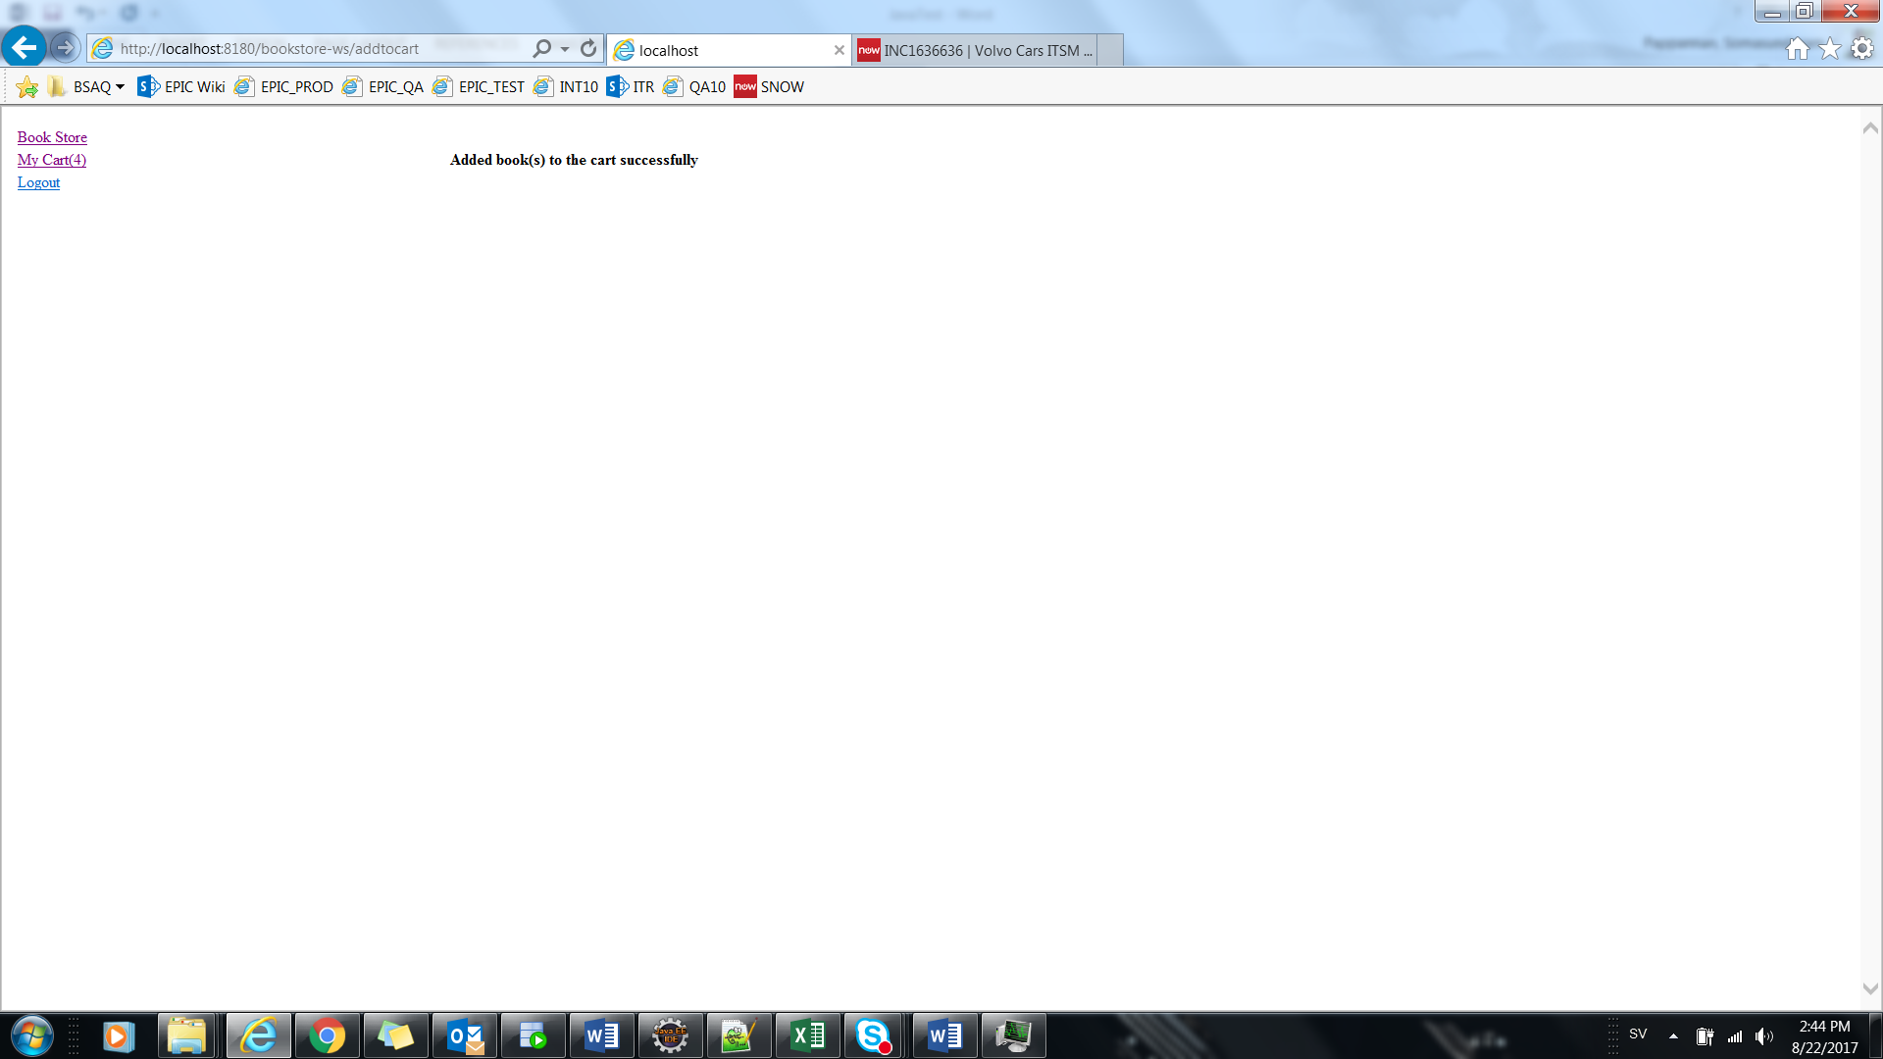

**My Cart Details:**

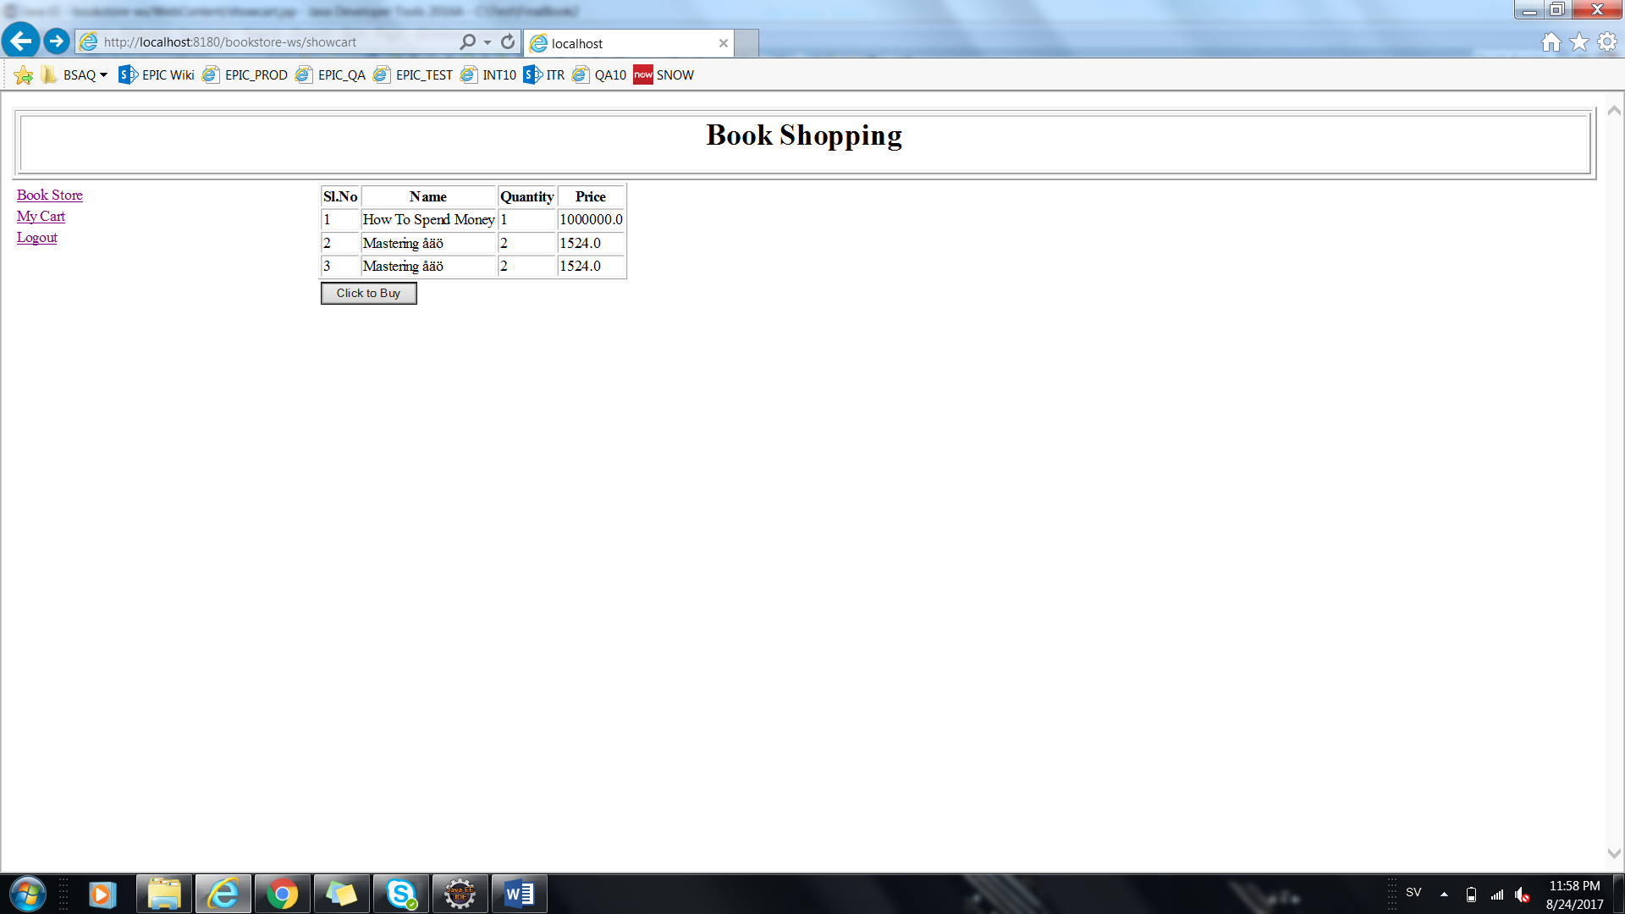

**Purchase Success:**

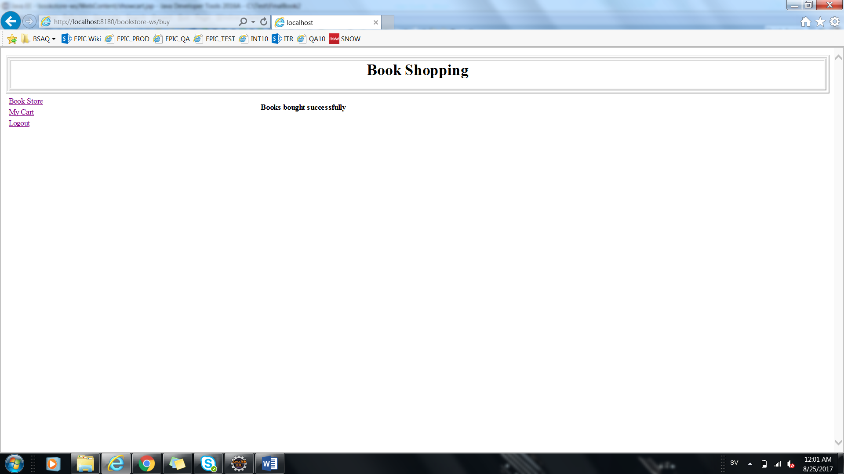

**Jars files Used:**

javax.json-1.0.4

javax.json-api-1.0

javax.servlet-api-3.0.1

javax.ws.rs-api-2.0.1

jaxb-api-2.2.7

jersey-client

jersey-common

jersey-container-servlet

jersey-container-servlet-core

jersey-media-json-binding-2.26-b08

jersey-media-json-jackson-2.13

jersey-media-sse-2.5.1

jersey-server

validation-api-1.1.0.Final